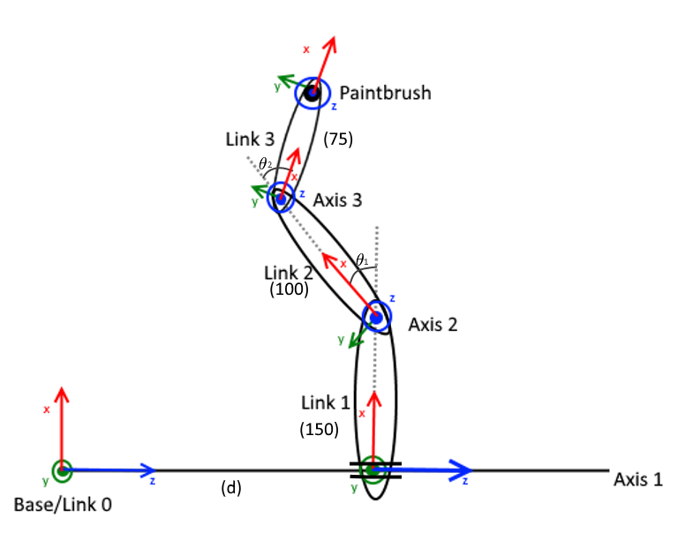

Slides 7 and 8 of lecture 4 show how to compose the matrices we need:

|  |  |  |  |  |
| --- | --- | --- | --- | --- |
| i | **αi-1** | **ai-1** | **di** | **Θi** |
| 1 | 0 | 0 | d | 0 |
| 2 | 90 | 150 | 0 | Θ1 |
| 3 | 0 | 100 | 0 | Θ2 |
| 4 (Brush) | 0 | 75 | 0 | 0 |

=

